Assignment # Name: Tarun Banda

Program 1: Geometry.java

**Screenshot (Sample Run) :**

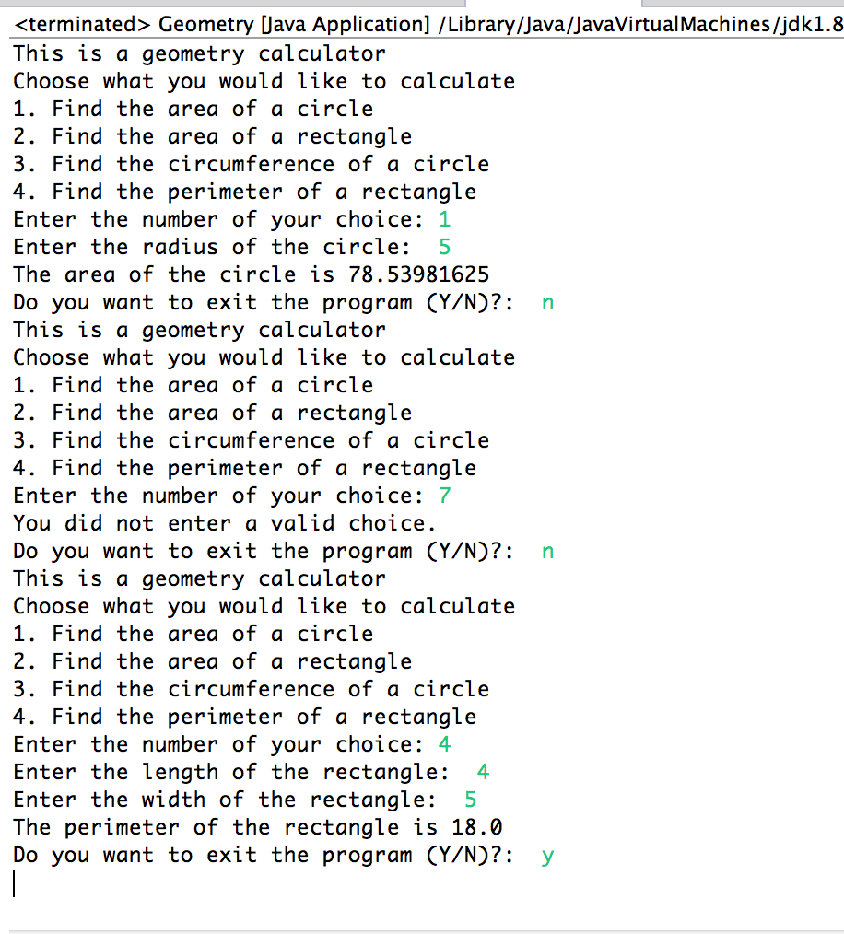

Program 2: AssignGrades.java

**Screenshot (Sample Run):**

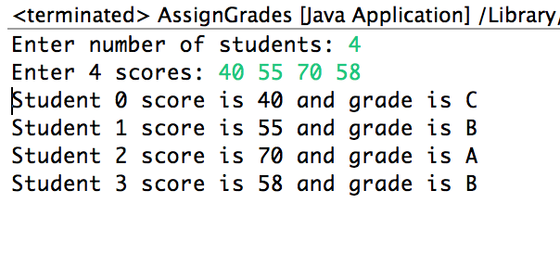

Program 3: Quizzes.java

**Screenshot (Sample Run):**

